**MODULE -- Spring Data JPA with Spring Boot**

**Task 1 : Configuring a Basic Spring Application**

**Code :**

**CountryRepository.java**

package com.cognizant.orm_learn.repository;

import org.springframework.data.jpa.repository.JpaRepository;

import org.springframework.stereotype.Repository;

import com.cognizant.orm_learn.model.Country;

@Repository

public interface CountryRepository extends JpaRepository<Country, String> {

}

**CountryService.java**

package com.cognizant.orm_learn.service;

import com.cognizant.orm_learn.model.Country;

import com.cognizant.orm_learn.repository.CountryRepository;

import org.springframework.beans.factory.annotation.Autowired;

import org.springframework.stereotype.Service;

import org.springframework.transaction.annotation.Transactional;

import java.util.List;

@Service

public class CountryService {

@Autowired

private CountryRepository countryRepository;

@Transactional

public List<Country> getAllCountries() {

return countryRepository.findAll();

}

}

**OrmLearnApplication.java**

package com.cognizant.orm_learn;

import com.cognizant.orm_learn.model.Country;

import com.cognizant.orm_learn.service.CountryService;

import org.slf4j.Logger;

import org.slf4j.LoggerFactory;

import org.springframework.boot.SpringApplication;

import org.springframework.boot.autoconfigure.SpringBootApplication;

import org.springframework.context.ApplicationContext;

import java.util.List;

@SpringBootApplication

public class OrmLearnApplication {

private static final Logger LOGGER = LoggerFactory.getLogger(OrmLearnApplication.class);

private static CountryService countryService;

public static void main(String[] args) {

ApplicationContext context = SpringApplication.run(OrmLearnApplication.class, args);

LOGGER.info("Inside main");

countryService = context.getBean(CountryService.class);

testGetAllCountries();

}

private static void testGetAllCountries() {

LOGGER.info("Start");

List<Country> countries = countryService.getAllCountries();

LOGGER.debug("countries={}", countries);

LOGGER.info("End");

}

}

**Output :**

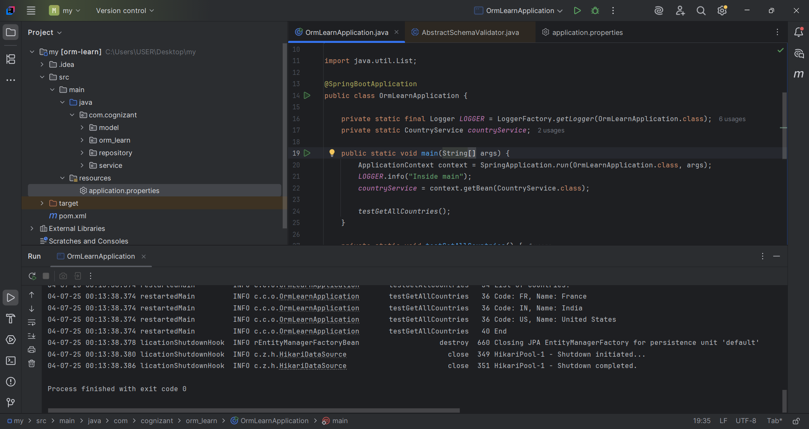

**Database Output:**

